**PROG8440 – Software Quality**

Selenium / Automation Testing

You are going to perform some automation testing using Selenium and the Selenium IDE. Along with this document, you will find a zip file for the website that you will be testing. Unzip the contents of this file directly into your **\htdocs** folder for where you have your XAMPP – Apache Server installation as shown:



Ensure that your Apache server is up and running (if not, start it up from the XAMPP Console).

To access the Website, go to: <http://localhost/PROG8440Assignment4.html>

You should see something like the following:

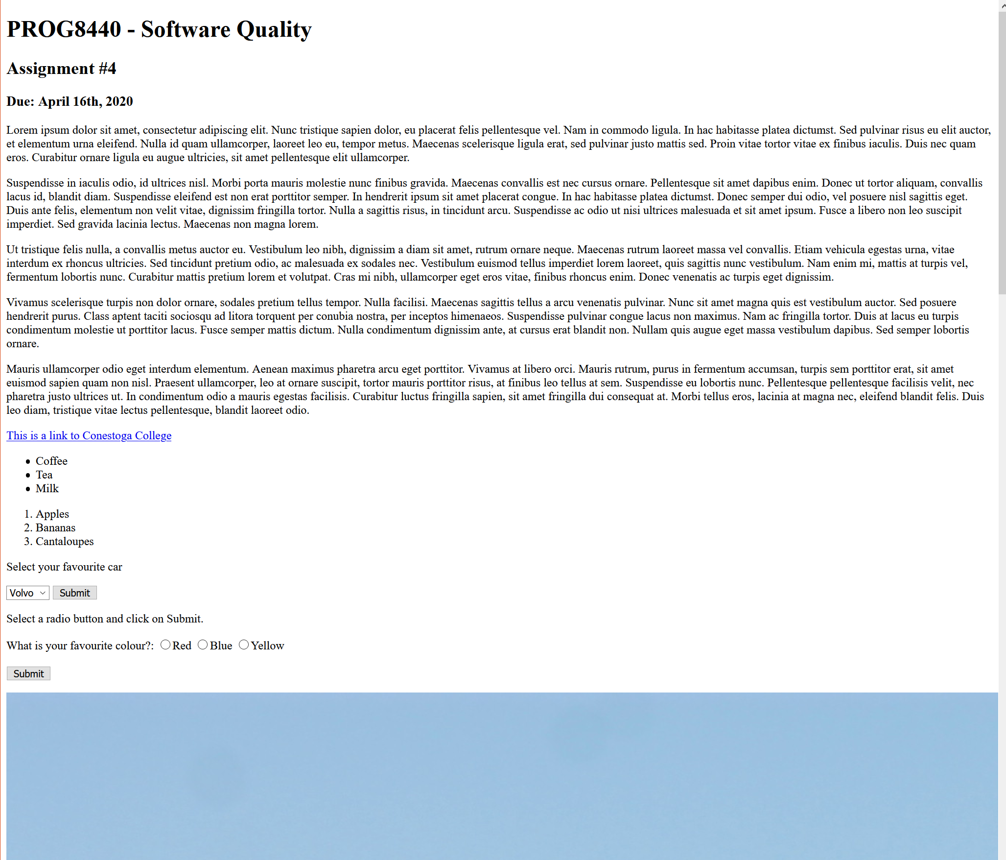

(be sure to scroll down to see the entire website)

**Task**

For this assignment, you are going to develop twenty (20) unique, automated system test cases for testing this website. These tests will be developed using Python using the Selenium testing framework. You may use the Selenium IDE to record and export your tests if you wish.

You need to be able to test the elements that are visible on this Website and run them through Spyder or another applicable Python IDE such as PyCharm, VisualCode, VisualStudio, etc.

Once you have developed your test code, save the code as a python file. Once you’ve run your test cases in Spyder (or another Python IDE), capture the result as a screenshot.

Capture a video (using your phone or any other screen recording software) of your test cases running on your computer. You should also explain what is going on for each test in your own voice. Upload your video as part of your submission. Please save your video with the .mp4 extension.

All of your tests must be run only on the Chrome browser and be sure to provide the proper naming conventions.